**VISVESVARAYA TECHNOLOGICAL UNIVERSITY**

Jnanasangama, Macche, Santibastwada Road

Belagavi-590018, Karnataka



**A**

**Mini Project Work(18EC6ICMPR) Report**

on

**AUTONOMOUS FLOOR CLEANING ROBOT**

*Submitted in partial fulfillment of the requirement for the degree of*

**Bachelor of Engineering**

*in*

**Electronics & Communication Engineering**

*by*

**1DS18EC083 – Sharanya S**

**1DS18EC085 - Shashidhar T**

**1DS18EC090 – Spoorthy M K**

**1DS18EC097 – Vanishree G B**

Under the guidance

of

**Dr. K P SHASHIKALA**

Mini Project Guide

Designation, ECE Dept., DSCE, Bengaluru



**Department of Electronics & Communication Engineering**

(An Autonomous College affiliated to VTU Belgaum, accredited by NBA & NAAC)

Shavige Malleshwara Hills, Kumaraswamy Layout,

Bengaluru-560078, Karnataka, India

**2020-21**

# Certificate

Certified that the Mini project work entitled “AUTONOMUS FLOOR CLEANING ROBOT” carried out by Sharanya S (1DS18EC083), Shashidhar T (1DS18EC085),

Spoorthy M K (1DS18EC090), Vanishree G B (1DS18EC097) are bonafide students of Dayananda Sagar College of Engineering, Bangalore, Karnataka, India in partial fulfillment for the award of Bachelor of Engineering in Electronics &Communication Engineering of the Visvesvaraya Technological University, Belagavi, Karnataka during the academic year 2020-21. It is certified that all corrections / suggestions indicated for Mini project work have been incorporated in the report deposited to the ECE department, the college central library & to the university. This Mini project report **(18EC6ICMPR)** has been approved as it satisfies the academic requirement in respect of project work prescribed for the said degree.

**________________________________ _________________________**

Dept. Project Coordinator Convener Project Guide

Dr. Roopa M Prof. XYZ

**__________________________ ________________________**

Head of the Department Dr. C.P.S. Prakash

Dr. T.C.Manjunath Principal

External Project Viva-Voce

Name of the project examiners:

1 : Signature : _____________________

2 : Signature : _____________________

# Declaration

Certified that the Mini project work entitled, “AUTONOMOUS FLOOR CLEANING ROBOT” is a bonafide work that was carried out by ourselves in partial fulfillment for the award of degree of Bachelor of Engineering in Electronics & Communication Engg. of the Visvesvaraya Technological University, Belagavi, Karnataka during the academic year 2020-21. We, the students of the Mini project group/batch no. B-16 hereby declare that the entire Mini project work has been done on our own & we have not copied or duplicated any other’s work. The results embedded in this Mini project work report has not been submitted elsewhere for the award of any type of degree.

Student Name :Sharanya S USN : 1DS18EC083

SIGN:_____________________

Student Name: ShashidharT

USN:1DS18EC085

SIGN:__________________

Student name: Spoorthy M K

USN:1DS18EC090

SIGN: ___________________

Student Name: Vanishree G B

USN:1DS18EC097

SIGN:___________________

Date :

Place : Bengaluru -78

**Abstract**

Home automation is a field focusing on making everyday household works simple and automatic for the comfort of human life. The principal point of this mini project is to design and develop an Autonomous Floor Cleaning Robot which can perform cleaning task. It can be controlled by an Android device as well as automatically by using a sensor for cleaning most part of the dirty floors and surfaces. The robot is able to avoid obstacles and must be capable of cleaning the room upon user commands. Cleaning section consists of a mop attached to the robot for mopping the floor. It is attached to a small water container from which water is sprayed by a mini water pump in order to make the mop wet. All hardware and software operations are controlled by Arduino Nano microcontroller. A Bluetooth module has been used for wireless communication between the robot and the user and an ultrasonic sensor is used to find the obstacles on its path. According to user convenience, mode of mopping can be selected. i.e., automatic mode or manual mode. This can be helpful in improving the lifestyle of mankind. There were many methods are available for cleaning the premises. But those methods were tedious, scary and needed high effort.. Using conventional floor cleaner needs a lot of effort and supervision from the user. As cleaning in areas where presence of living being is dangerous, the existed system was not considered as an efficient method. As the improvement in the innovation of technology with the help of automation this task was made much more efficient and easier.

**Table of Contents**

Title sheet 1

Certificate 2

Declaration 3

Abstract 4

Table of contents 5

|  |  |
| --- | --- |
| Chapter 1: Introduction | 6 |
| Chapter 2: Literature survey | 7 |
| Chapter 3: Methodology | 8 |
| Chapter 4: Block diagram and Implementation | 9 |
| Chapter 5: Results and Discussions | 10 |
| Chapter 6: Conclusion and Future work | 11 |
| Chapter 7: References | 12 |

**CHAPTER 1 INTRODUCTION**

From the very beginning of the human era, cleaning was one of the tedious and time-consuming tasks. Technologies are part of human life and help them in order to complete their tasks. There were many methods are available for cleaning the premises. But those methods were tedious, scary and needed high effort. People using sweep and mop for cleaning the households. It became difficult for working people to find time for cleaning. Most of the people usually using a hand-controlled mop for mopping the floor. So, there might be chances to reduce manpower and human efforts. Using conventional floor cleaner needed a lot of effort and supervision from the user. Because of these difficulties, the existed system was not considered as an efficient method.

As the improvement in the innovation of technology, with the help of automation, this task was made much more efficient and easier. The robotic cleaners have taken major attention in robotics research due to their effectiveness in assisting humans in floor cleaning applications at homes, hotels, restaurants, offices, hospitals, warehouses, and educational institutions, etc. It is an electromechanical machine and used for various purposes in domestic applications. Although devices such as washing machines and dishwashers have served this purpose, it still requires some degree of human input effort. In developing a floor cleaning robot, there are several challenges that one has to come in front, i.e. the method of cleaning, path planning, covering the whole floor surface, cleaning it completely, maintenance so on and so forth. It becomes even more complicated when safety, economy, energy consumption is considered to be at the optimum level.

Initially, the main focus was on having a household cleaning device robot. Basically, the robotic cleaners are classified on their cleaning technique like floor mopping, dry vacuum cleaning, sweeping, etc. Some robotic cleaners are based on simple obstacle avoidance using infrared sensors while some utilize laser mapping technique for navigation.

All cleaning and operating mechanism of robotic floor cleaners have their own advantages and disadvantages. For example, robots utilizing mapping technique are relatively faster, and energy efficient but these are costly, while obstacle avoidance based robotic cleaners are relatively less time consuming and less energy efficient due to random cleaning of the floor. The main purpose of this project is to design and develop an automatic floor-cleaning robot that will make mopping operations more efficient and easier. It reduces the cost of cleaning and human efforts. It will assist people at home who are too busy for daily floor cleaning, especially for job working people who do not have enough time to clean. In particular for the elderly people who live by themselves and do not have the strength or ability to clean.

* 1. **EXISTING SYSTEM:**

People used sweep and mop for cleaning the households. It became difficult for working people to find time for cleaning. Most of the people usually using a hand-controlled mop for mopping the floor. So, there might be chances to reduce manpower and human efforts. Cleaning the floor especially in the kitchen, under the sofa, beds and tables is one of the annoying chores that must be performed on a regular basis in order to avoid a build-up of debris. The standard method for floor cleaning i.e. using mop and water is time consuming and labour intensive which results in scheduled floor cleaning and being skipped for other reasons. Also, this method can’t be used in the places where the Humans are restricted to go but cleaning is necessary. For example - nuclear power plant installed places, Hospitals, Chemical industry etc.

**1.2 PROBLEM STATEMENT:**

Cleaning is important work approximate every place. Sometimes this is easy and sometimes difficult. Sometimes we assigned people for purpose of cleaning and pay money and sometimes cleaning is required in areas where presence of living being dangerous so we cannot assign living being in every place. In such a situation an individual will always find ways of saving time.

* For career oriented and dealing women it's hard to handle home together with job work.
* Normally floor is cleaned with the utilization of dry mopped or wet mopped using the hand as a base tool. they need to be scrubbed hard on the surface.
* The cleaning module includes cleaning of varied surfaces like cement floors, highly polished wooden or marble floors.
* The rough surface areas like cement floor, are covered with heavy dust which consumes longer in cleaning.

**CHAPTER 2: LITERATURE SURVEY**

Floor cleaning robot may be a trending concept in these recent days. By reviewing different paperwork and techniques of used several cleaning robots, we've started acting on our design of floor cleaning robot which is predicated on Arduino NANO model. The papers surveyed for literature surveys are as follows:

* Aishwarya Pardeshi presents the look, developed and fabricated model of programmed cleaner robot. This type of robot performs automated function with extra features like choose and place mechanism and dirt container with air vacuum mechanism. this type of labour is straightforward and helpful in betterment of life variety of a mankind.
* Ajith Thomas proposed an autonomous robotic for floor cleaning program. it's able to perform sucking and cleaning, detection of obstacles, and water spraying. Furthermore, it's also able to add manual method. All hardware and software functions are manipulated by Raspberry pi3 model.
* Vaibhavi Rewatkar and Sachin T. Bagde provided a comprehensive overview of the technological advantages helped within the real world for the convenience of just about all of the people that are extremely busy. Consequently, this has led to arriving up with a goal of constructing an automatic home appliance. The review includes computerized cleaner having components to DC motor operated wheels, the dustbin, cleansing brush, mop cleansing and obstruction avoiding sensor. A 12V battery is employed for supplying power. Special technique of ULTRAVIOLET germicidal cleaning technology. The study has been done keeping in mind economical expense of product.
* Vinod J Thomas designed a cleaner robot for domestic application. The robotic contains a cleaning module which may be used for cleaning. The Robot was created in order that it may well be capable of reach almost every space and corner of any room that it must be as compact as possible. The working robot is handled using an Android phone using Wireless Bluetooth Technology. The robot was created with an Arduino microcontroller at its core. The microcontroller is complemented with communications modules like Wireless Bluetooth motors and dirt Suction System to work accordingly.
* Manya Jain discussed the event of Automatic Floor Cleaner. The project is often used for domestic and professional purpose to scrub the surface automatically and manually. When it's turned ON, it gulps within the dust particles by moving everywhere the surface (floor or the other area) because it moves over it. the driving force control mechanism are often wont to drive the motors where robot having the ability to manoeuvre and also the also few sensors are accustomed detect and avoid the obstacles. this can be often useful in making the approach to life better for humankind.
* Akash Choudhary targeted to form a totally automated hybrid home cleaning robot. Which is fully automated and may perform tasks like mopping and cleaning of floor. After the testing we discover that it can perform all tasks fine with none hurdle. We tested our robot on various parameters like path following, obstacle avoidance, navigation, mopping and vacuum mechanism
* Karthick.T is intended to create up an autonomous automatic robot which will move itself without constant human instruction. The autonomous cleanser robot involves low power consuming electric components, and it can operate at very low power. Electric parts are the controller board Atmega 2560, Ultrasonic detectors, transformer IC and motor driver circuit. Mechanized part is motor unit with gearbox founded. Ultrasonic detectors will identify obstructions in line with the program being executed. A 12V, 4.5Ah rechargeable lead acid electrical device is that the energy source for this proposed cleaning

automatic robot.

**RELATED PAPERS:**

* P. Aishwarya, S. More, D. Kadam, V.A. Patil, “Automatic Floor Cleaner”, IJECT vol. 8, 2017.
* T. Ajith, M. S. Rohith, J. Febin, J. Cheriyan, R, Mary George, “An Advanced Mobile Robot for Floor Cleaning”, International Journal of Advanced Research in Electrical, Electronics and Instrumentation Engineering, vol. 5, no. 3, 2016.
* R. Vaibhavi and S. T. Bagde, “A Review on Design of Automated Floor Cleaning System”, International Journal on Recent and Innovation Trends in Computing and Communication, vol. 3, no. 2.
* V. J Thomas, B. Xaviour, J. K George, “Cleaner Robot”, International Journal of Emerging Technology and Advanced Engineering, ISSN 2250-2459, ISO 9001:2008 Certified Journal, vol. 5, no. 12, 2015.
* M. Jain, P. S. Rawat, J. Morbale, “Automatic Floor Cleaner”,International Research Journal of Engineering and Technology (IRJET), vol. 4, no. 4 , 2017.
* T. Karthick, A. Ravikumar, L. Selvakumar, T. Viknesh, B. Parthiban. And A.Gopinath, “Simple Autonomous cleaner Robot”, International Journal of Science, Engineering and Technology Research (IJSETR), vol. 5, no.3, 2016.

**CHAPTER 3: METHODOLOGY**

Behavioural approaches are used to autonomously or manually operates and control the cleaning robot. Arduino IDE is an official Arduino software, making code compilation too easy that even a common person with no prior technical knowledge can get their feet wet with the learning process. It is easily available for operating systems like MAC, Windows, Linux and runs on the Java Platform that comes with inbuilt functions and commands that play a vital role for debugging, editing and compiling the code in the environment. A range of Arduino modules available including Arduino Uno, Arduino Mega, Arduino Nano , Arduino Micro and many more. Each of them contains a microcontroller on the board that is actually programmed and accepts the information in the form of code. The main code, also known as a sketch, created on the IDE platform will ultimately generate a Hex File which is then transferred and uploaded in the controller on the board. The IDE environment mainly contains two basic parts: Editor and Compiler where former is used for writing the required code and later is used for compiling and uploading the code into the given Arduino Module.

In this project we use Arduino Nano which is a open-source software in which hardware can be easily used. It is the main controller used to control the cleaning robot.

Arduino Bluetooth controller app controls cleaning robot with an android device. This app communicates using Bluetooth to a Bluetooth module in the robot. An ultrasonic sensor is used for obstacle detection which transmits the ultrasonic waves from its sensor head and again receives the echo waves and sends its output signal to the Arduino Nano. It will stop the robot immediately and take right or left turns. The ultrasonic sensor is connected with the servomotor, which helps in the rotation of ultrasonic sensor. The ultrasonic sensor measures the distance between the robot and the obstacle in front of it. If any obstacle is present in front of the robot, L293D driver circuit is used to drive the DC motors simultaneously in all of the direction. Arduino Nano sends the signal to the motor driver circuit that controls and drives the wheel.

Movement of the robot

Design of the system began with considering the path for cleaning the floor surface. With the assumption that the area in which the robot was to operate was a rectangle, two options for the desired path were identified, a spiral path or a zigzag path. The two patterns of the path were compared against each other while concurrently considering simplicity, effectiveness, completion time, and sensor position. The operation of the floor cleaning robot during the zigzag pattern would be dependent on the position of the sensors. There are two possibilities to strafe from wall to wall or to drive forwards and perform a 180° turn at each wall. The option to turn 180 degrees at the wall was relatively complex and slower than the spiral pattern due to the number of operations are required to turn 180 degrees and find the new path across the area.

**CHAPTER 4 : BLOCK DIAGRAM & IMPLEMENTATION**

**Hardware Components:**

**L293D Motor Driver Module:**

Fig 1

A motor driver IC is an integrated circuit chip which is usually used to control motors in autonomous robots. Motor driver ICs act as an interface between microprocessors in robots and the motors in the robot. The most commonly used motor driver IC’s are from the L293 series such as L293D, L293NE, etc.

The L293D is a 16 pin IC, with eight pins, on each side, dedicated to the controlling of a motor. There are 2 INPUT pins, 2 OUTPUT pins and 1 ENABLE pin for each motor. L293D consist of two H-bridge. H-bridge is the simplest circuit for controlling a low current rated motor.

### **Arduino Nano:**

The Arduino Nano is a small, complete, and breadboard-friendly board based on the ATmega328 (Arduino Nano 3.0).

It offers similar connectivity and specs to the Arduino Uno Rev3 and lacks only a DC power jack, and works with a Mini-B USB cable instead of a standard one.

Specifications:

|  |  |
| --- | --- |
| Microcontroller | ATmega328 |
| Operating Voltage | 5V |
| Input Voltage (recommended) | 7 – 12 V |
| Input Voltage (limit) | 6 – 20 V |
| Digital I/O Pins | 14 |
| PWM Digital I/O Pins | 6 |
| Analog Input Pins | 8 |
| DC Current per I/O Pin | 40 mA |
| Flash Memory | 32 KB (2KB used by bootloader) |
| Flash Memory for Bootloader | 2 KB |
| SRAM | 2 KB |
| EEPROM | 1 KB |
| Clock Speed | 16 MHz |

### **HC-05 Bluetooth Module:**

### Bluetooth Module is an easy-to-use Bluetooth SPP (Serial Port Protocol) module, designed for transparent wireless serial connection setup. Its communication is via serial communication which makes an easy way to interface with controller or PC. HC-05 Bluetooth module provides switching mode between master and slave mode which means it able to use neither receiving nor transmitting data.

### Specification:

### Model: HC-05

### Input Voltage: DC 5V

### Communication Method: Serial Communication

### Master and slave mode can be switched

### **Ultrasonic Sensor Module:**

**Ultrasonic (US) sensor** is a 4 pin module, whose pin names are Vcc, Trigger, Echo and Ground respectively. This sensor is a very popular sensor used in many applications where measuring distance or sensing objects are required. The module has two eyes like projects in the front which forms the Ultrasonic transmitter and Receiver. The sensor works with the simple high school formula that

**Distance = Speed × Time**

### The Ultrasonic transmitter transmits an ultrasonic wave, this wave travels in air and when it gets objected by any material it gets reflected back toward the sensor this reflected wave is observed by the Ultrasonic receiver module as shown in the picture below

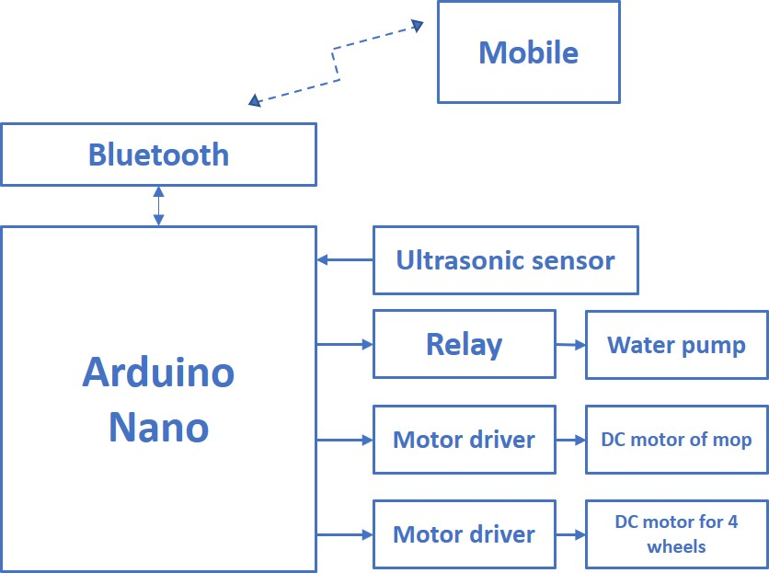**BLOCK DIAGRAM:**

**IMPLEMENTATION:**

The Proposed block diagram consists of an Arduino Nano, Ultrasonic sensor, L293D motor driver, Relay, 100rpm gear motor. When the system is first booted, the user has to choose between automatic or manual mode by connecting to Arduino Nano through Bluetooth. If the automatic mode is selected then the reading from the ultrasonic sensor is read to check if there are any obstacles/walls on the way to mopping. If an obstacle/wall is detected then based on the turn count that is odd or even, the robot turns right or left respectively along with pumping the required amount of water on the floor and mopping the floor. Manual mode is selected in case of unexpected situations that the robot can't handle, in this mode; the robot is controlled by the user through the android phone. The control software is designed using the Arduino IDE.

The algorithm relates the factors responsible for the autonomous and manual movement with the robot peripheral elements by means of the sequence of events performed by each factor.

According to the programming instructions in the Arduino Nano as the robot starts moving the mop fixed in the front part of the robot starts cleaning. The moping operation can be started or stopped at any point of time as per the requirement. The moping brush is actuated by the DC motor fixed to it. signal to this motor is fed by the controller.

**Software Implementation**

**Program**

// ---------------------------------------------------------------- //

// Arduino Ultrasoninc Sensor HC-SR04

// Re-writed by Arbi Abdul Jabbaar

// Using Arduino IDE 1.8.7

// Using HC-SR04 Module

// Tested on 17 September 2019

// ---------------------------------------------------------------- //

#define echoPin 12 // attach pin D2 Arduino to pin Echo of HC-SR04

#define trigPin 11 //attach pin D3 Arduino to pin Trig of HC-SR04

// defines variables

long duration; // variable for the duration of sound wave travel

int distance; // variable for the distance measurement

void setup() {

pinMode(trigPin, OUTPUT); // Sets the trigPin as an OUTPUT

pinMode(echoPin, INPUT); // Sets the echoPin as an INPUT

Serial.begin(9600); // // Serial Communication is starting with 9600 of baudrate speed

Serial.println("Ultrasonic Sensor HC-SR04 Test"); // print some text in Serial Monitor

Serial.println("with Arduino UNO R3");

}

void loop() {

// Clears the trigPin condition

digitalWrite(trigPin, LOW);

delayMicroseconds(2);

// Sets the trigPin HIGH (ACTIVE) for 10 microseconds

digitalWrite(trigPin, HIGH);

delayMicroseconds(10);

digitalWrite(trigPin, LOW);

// Reads the echoPin, returns the sound wave travel time in microseconds

duration = pulseIn(echoPin, HIGH);

// Calculating the distance

distance = duration * 0.034 / 2; // Speed of sound wave divided by 2 (go and back)

// Displays the distance on the Serial Monitor

Serial.print("Distance: ");

Serial.print(distance);

Serial.println(" cm");

}

// ---------------------------------------------------------------- //

// Arduino Ultrasoninc Sensor HC-SR04

// Re-writed by Arbi Abdul Jabbaar

// Using Arduino IDE 1.8.7

// Using HC-SR04 Module

// Tested on 17 September 2019

// ---------------------------------------------------------------- //

#define echoPin 2 // attach pin D2 Arduino to pin Echo of HC-SR04

#define trigPin 3 //attach pin D3 Arduino to pin Trig of HC-SR04

#define echoPin1 4 // attach pin D2 Arduino to pin Echo of HC-SR04

#define trigPin1 5 //attach pin D3 Arduino to pin Trig of HC-SR04

// defines variables

long duration,duration1; // variable for the duration of sound wave travel

int distance,distance1; // variable for the distance measurement

int temp, t1,t2;

void setup() {

pinMode(trigPin, OUTPUT); // Sets the trigPin as an OUTPUT

pinMode(echoPin, INPUT); // Sets the echoPin as an INPUT

pinMode(trigPin1, OUTPUT); // Sets the trigPin as an OUTPUT

pinMode(echoPin1, INPUT); // Sets the echoPin as an INPUT

Serial.begin(9600); // // Serial Communication is starting with 9600 of baudrate speed

}

void loop() {

// Clears the trigPin condition

digitalWrite(trigPin, LOW);

delayMicroseconds(2);

// Sets the trigPin HIGH (ACTIVE) for 10 microseconds

digitalWrite(trigPin, HIGH);

delayMicroseconds(10);

digitalWrite(trigPin, LOW);

digitalWrite(trigPin1, LOW);

delayMicroseconds(2);

// Sets the trigPin HIGH (ACTIVE) for 10 microseconds

digitalWrite(trigPin1, HIGH);

delayMicroseconds(10);

digitalWrite(trigPin1, LOW);

// Reads the echoPin, returns the sound wave travel time in microseconds

duration = pulseIn(echoPin, HIGH);

// Calculating the distance

distance = duration * 0.034 / 2; // Speed of sound wave divided by 2 (go and back)

// Displays the distance on the Serial Monitor

// Reads the echoPin, returns the sound wave travel time in microseconds

duration1 = pulseIn(echoPin1, HIGH);

// Calculating the distance

distance1 = duration1 * 0.034 / 2; // Speed of sound wave divided by 2 (go and back)

// Displays the distance on the Serial Monitor

if (distance <= 30 )

{

Serial.println(distance);

Serial.println("Wall detected");

delay(3000);

temp = distance1 ;

Serial.println(temp);

t1 = temp + 3 ;

t2 = temp - 3 ;

Serial.println(t1);

Serial.println(t2);

store_value();

}

else

{

Serial.println(distance1);

Serial.println("Moving forward");

delay(700);

}

}

void store_value()

{

while(1)

{

if ((distance <= t1 ) && (distance >= t2))

{

Serial.println("STOP");

delay(1000);

}

else

{

Serial.println("turning left");

Serial.println(distance);

delay(500);

}

}

}

**CHAPTER 5: RESULT AND DISCUSIONS**

The path followed by the robot is in “Rectangular” shape, and it gives the best result for the cleaning cycle with less time. The robot is connected with batteries and whose cleaning and moving system is controlled by a DC gear motor and pump. This technique is eco-friendly, and this work is an attempt to reduce accidents while in critical driving conditions. We have tested the working of the system by placing various objects ahead as obstacles. The system responded by reducing the speed of the vehicle when the obstacle is placed at various distances from it.

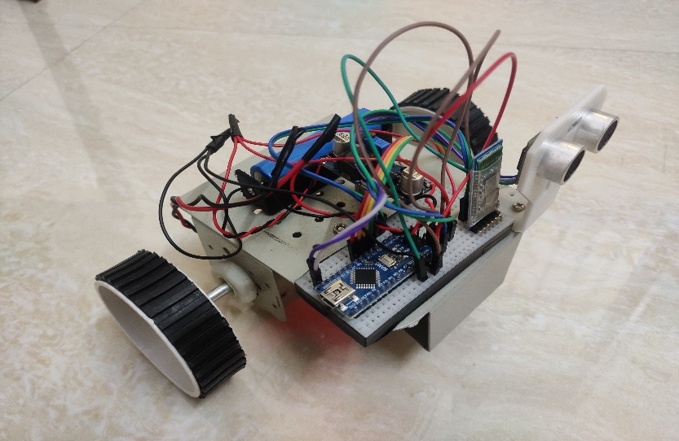

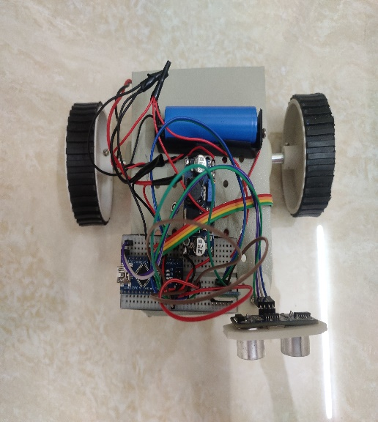

**CHAPTER 6: CONCLUSION AND FUTURE WORK**

**6.1 CONCLUSION:**

This project helps to design and development of Autonomous floor cleaning robot.

* This concept has been to be an efficient way of saving time and helping physically disabled people.
* As specified the user can switch on the device and go for any other work and the robot will automatically mop the floor by detecting and avoiding the obstacles on its way.
* The structure of the robot can be made more attractive for better acceptance at home or office environments.
* It is dependent on DC power supply and favourable for battery, especially for long operation and cost-effectiveness. The zigzag motion algorithm used does not require any navigation system and ensures the complete filling of the area.
* The rectangular motion occurs when the robot encounters the walls or other objects. A person can wirelessly control the robot using the android app as well. The cost of floor mopping robot is significantly reduced to less than 50 to 60 % of the currently available mops in the market. The estimated cost of equipment is INR 5000

**6.2 FUTURE WORK:**

GSM modules can be added to the domestic robots making them easy to operate and accessible from any part of the world and send a message that, the robot has done the cleaning task. And other sensors can be used for detecting waste and obstacles. The camera can also be added for navigation purposes.

We can also use 2-D mapping to generate a map of the surface to clean it.

The mapping and obstacle avoidance could have been well served with a 180-degree LIDAR sensor.

These sensors have incredible refresh rates and great accuracy that along with some rotary encoders on the wheels could have plotted an excellent map and kept track of obstacles with ease.

The chassis can be built on a PVC polymer. This will reduce the overall weight of the system. Germ less cleaning using UV exposure can be installed on the system.

**REFERENCE**

[1]S.Muruganandhan , G.Jayabaskaran, P.Bharathi, “LabVIEW-NI ELVIS II based Speed Control of DC Motor,” International Journal of Engineering Trends and Technology (IJETT) Volume 4 Issue 4, April 2013

[2] A Technical Analysis of Autonomous Floor Cleaning Robots Based on US Granted Patents, European International Journal of Science and Technology Vol. 2 No. 7 September 2013. Liu, Kuotsan1, Wang, Chulun

[3] Dong Sun, Jian Zhu and Shiu Kit Tso (2007) ‘A Climbing Robot for Cleaning Glass Surface with Motion Planning and Visual Sensing’ Climbing and Walking Robots, Book edited by Houxiang Zhang ISBN978-3-902613-16-5, pp.546

[4] Jens-Steffen Gutmann, Kristen Culp Mario, E. Munich Paolo Pirjanian, “The Social Impact of a Systematic Floor Cleaner”, “Proceedings of the 2012 IEEE International Workshop on Advanced Robotics and its Social Impacts, Technische Universität München, Munich, Germany”, May 21 - 23, 2012, pp. 50-53.

[5] Manisha Kukde, Sanchita Nagpurkar, Akshay Dhakulkar, Akshay Amdare, “Automatic & Manual Vacuum Cleaning Robot”, “International Research Journal of Engineering and Technology (IRJET)”, Vol. 05, Issue: 02, Feb-2018, pp. 2196-2198.

[6] Manreet Kaur and Preeti Abrol, “Design and Development of Floor Cleaner Robot (Automatic and Manual)”, “International Journal of Computer Applications (0975 – 8887)”, Vol.

[6] Evolution Robotics Inc. Introducing Mint-the evolution of floor care, www.mintcleaner.com,2011. [7] J-S. Gutmann, E.Eade, P.Fong and M.E. Munich. Vector field SLAM. IN Int. conf. on Robotics and automation (ICRA), 2010.

[8] J-Y. SUNG, R.E.Grinter, and H.I.Chrstensen, and L.Go.Housewives domestic robot technology int. Journal of social robotics, 2(4):417- 429,2010. 97, No.19, July 2014.

[9] Prof. Taware R. D., Vaishali Hasure, Puja Ghule, Komal Shelke, “Design and Development of Floor Cleaner Robot (Automatic and Manual Mode)-2017 IJRTI” Vol. 2, Issue 4, pp. 57-60.

[10] Yunbo Hong, Rongchuan Sun, Rui Lin, Shumei Yu, and Lining Sun, “Mopping module design and experiments of a multifunction floor cleaning robot”, “Proceeding of the 11th World Congress on Intelligent Control and Automation, Shenyang, China”, June 29 -July 4, 2014, pp. 5097-5102.